Browsing Online Repositories

The vast amount of data stored in PRIDE1 can be accessed via the web interface or viewed in PRIDE Inspector2. Go on the PRIDE website (<http://www.ebi.ac.uk/pride>):

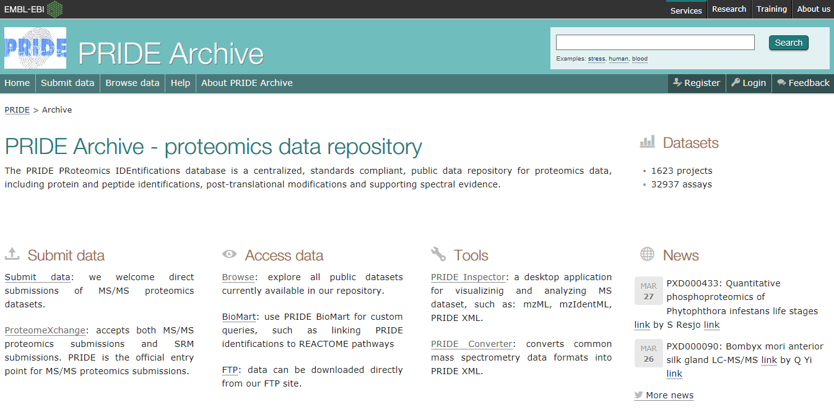

Under ‘Access data’ click on ’Browse ’ to browse the list of projects:

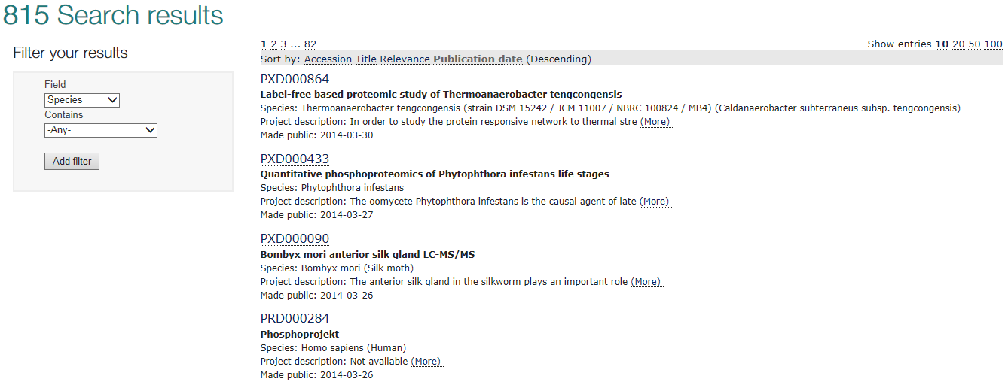

Click in a given dataset to see the project details available, for example:

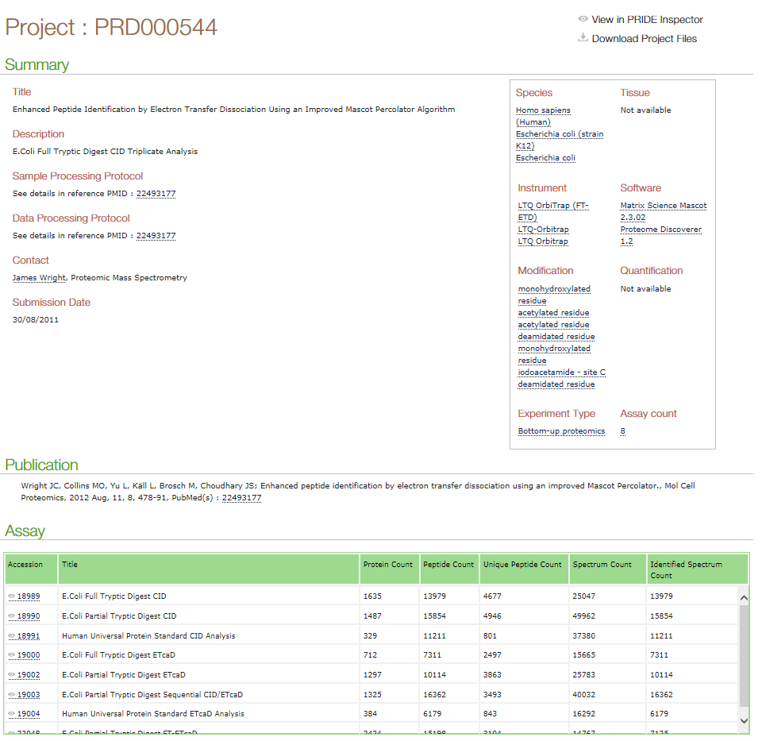

*What information can you access regarding this experiment? What is your opinion about making all data available? [3.2a]*

To further inspect the data you can use the 'View in PRIDE Inspector' or 'Download Project Files' in the upper right corner. However, to save time (and to get a familiar dataset) we will rather use the mzIdentML file we created in the previous chapter.

It is possible to browse all public PRIDE datasets and local PRIDE projects using PRIDE Inspector (<http://pride-toolsuite.googlecode.com>), available in the software folder. Starting PRIDE Inspector, you will see the following:

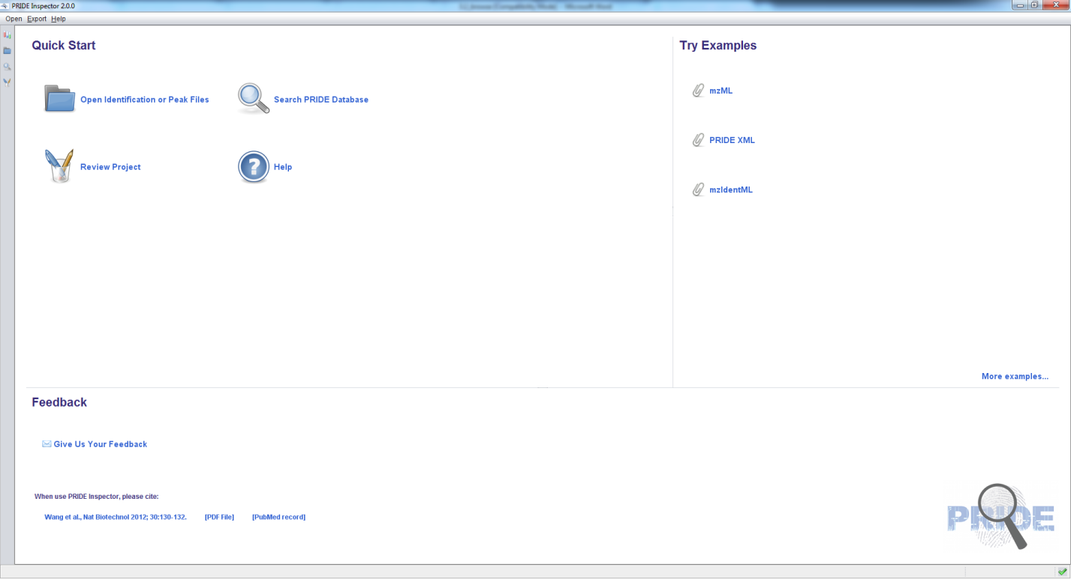

Select ‘Open Identification or Peak Files’ and open PeptideShaker_Tutorial.mzid located in the resources folder. When asked if you want to load the related spectrum files, select 'Yes' and locate the mgf file used for the search (also located in the resources folder). When done loading you should see the following:

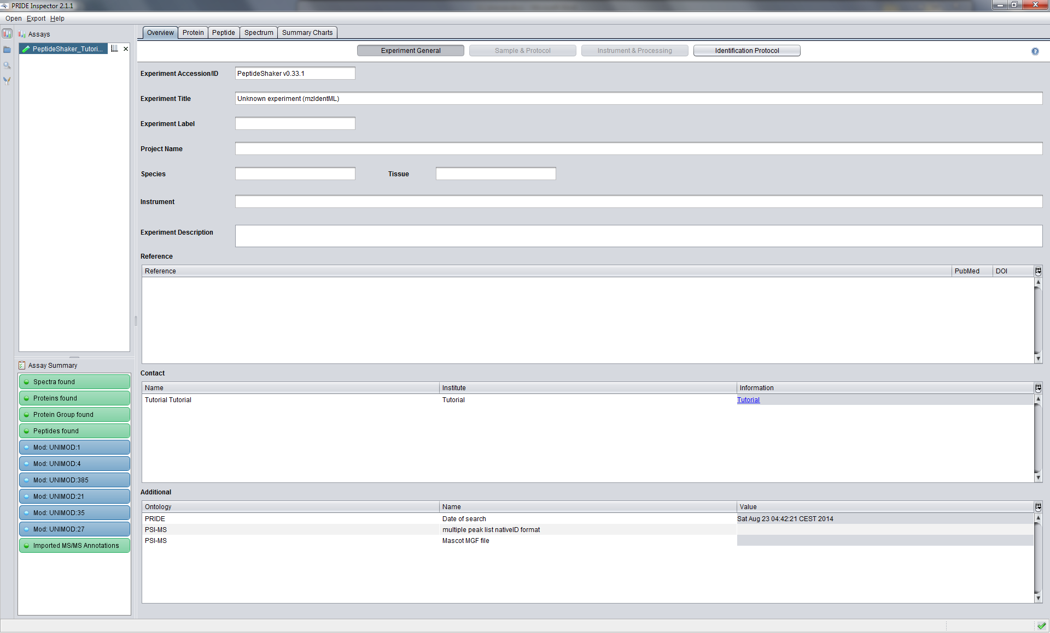

Note that all the spectrum annotations (modifications, ions, etc.) have been passed by PeptideShaker to PRIDE Inspector as standardized terms and will thus be available for other online resources. *What difference do you see compared to the PeptideShaker results? [3.2b]*

References

1. Martens, L. et al. PRIDE: the proteomics identifications database. *Proteomics* **5**, 3537-3545 (2005).

2. Wang, R. et al. PRIDE Inspector: a tool to visualize and validate MS proteomics data. *Nature biotechnology* **30**, 135-137 (2012).